Istruzioni per l’impaginazione dei lavori presentati al “XXVIII conGRESSO cta”, francavilla al mare (ch) 2022
Instructions for the preparation of manuscripts for “XXVII CONGRESSO CTA”, francavilla al mare (ch) 2022
FirstName FamilyName1,  FirstName FamilyName2  University of Xxxxxxxx  Department of Xxxxxxxx  Town, Country  EmailAddress | FirstName FamilyName3  University of Xxxxxxxx  Department of Xxxxxxxx  Town, Country  EmailAddress

Abstract
The abstract has to be written in both Italian and English language. In it the objectives of the study and the salient conclusions should be clearly stated. The length should be approximately from 100 to 200 words.

SOMMARIO
Questo è lo spazio per il sommario in Italiano.

1 Introduction
This manual has been prepared in the format that should be used for the preparation of manuscripts. Authors are free to write the manuscript in Italian or in English language.
All authors are requested to provide their contribution in electronic format either as Word (.docx) and as PDF file. The Proceedings from this XXVIII CTA Congress will be printed directly from the files submitted. In order to ensure that the electronic version is in accordance with the authors intention, every contribution shall be also sent as a printed copy. Use international A4 paper for the printed copy.
Please do not number your pages, the numbering will be done before printing the proceedings by the Publisher. Each contribution has to be limited to 8 pages in total, or to 4 pages in total in the case of short notes.

2 MAJOR HEADINGS
Major headings are typed in bold capitals, this is already pre-set in the format definition. They start at the left-hand margin on a separate line. The distances are pre-set in the format definition “headings major” to 12 pt before and 4 pt after the headings.

2.1 Secondary Headings
Secondary headings are typed in initial capitals (bold), start at the left-hand margin and on a separate line. The distances are pre-set in the format definition “Secondary Headings” to 10 pt before and 4 pt after the headings. Please limit the depth of headings to the proposed major and secondary headings.

2.2 Numbering of headings
This template does not provide automatic numbering of headings. It is authors choice to use numbering of headings or not; it is however recommended not to use automatic numbering, because the Word files (or PDF) will be used for printing and automatic numbering is sometimes misinterpreted depending on the computer or program settings. The format of the major and secondary headings is defined such, that after typing the number of the section a tab shall be used. The second line of long headings will be adjusted accordingly if no carriage return is used.

3 Page and paragraph format

3.1 Page size and margins
Please use the ISO A4 page format for preparing your manuscript. As the contributions will be delivered as electronic files it should be possible to save the document with the A4 page size.
Use bold capitals for the title with 12 pt bold lettering. If you have a long title, please consider a Title, Subtitle format (as used in this template).
The full name(s), current affiliation, including e-mail address of the author(s) must be given below the title. In this example a table was used to arrange the names of three authors. The abstracts of the paper and the start of text should appear on the first page.

3.2 Format templates
This guideline contains format templates for most of the usual types of text. In particular the following format templates shall be used:
- format templates for headings
- format template “paragraph” for the text
- format templates for the description of Tables and Figures
- format template for formulas
- format template for lists
The above listed format templates are recommendations intended to simplify the preparation of the manuscript. This template should also help to achieve a consistent appearance of all contributions.

4 Fonts to be used

4.1 Font family
The font family to be used for the preparation of the paper shall be Times, Times New Roman or similar. Please do not switch typeface families within a document. For Greek letter like α or Λ use either the Symbol font or the extended Greek subset of the standard font.

4.2 Fonts in figures and formulas
Please consider that, except in scanned images, the fonts used in figures, diagrams or formulas shall be widely available. In addition to the Times-family Arial or Helevetica fonts may be used in figures, as these font are usually available on any computer and printer. Other fonts should not be used.
In formulas there are normally no problems, when the standard setting are used. An example of a formula is given below
(1)
where capital Latin letter
small Latin letter
small Greek letter
capital Greek letter
The lines containing the list of variables is single spaced. Please use numbering of formulas when referring to them, e.g. see equation (1).

5 FIGURES AND TABLES

5.1 Figures
Clear illustrations enhance an article and often save words. It is imperative that all drawings and all lettering on illustrations be checked with great care before submission. Drawings should be done on the computer or be made on white paper with black waterproof drawing ink and scanned as black and white bitmaps into the page where they have to appear in the text. Scanned diagrams shall have a resolution of 600 DPI (minimum 300 DPI) for figures scaled to 100%. The preferable format for black and white images is tiff (compressed), jpeg is not recommended. Also WMF or EPS figures may be included when observing the hints given in 4.2.
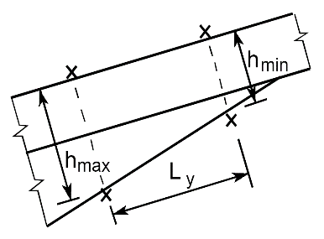  Fig. 1. Scanned image (high quality) | 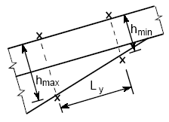  Fig. 2. Scanned image (poor quality)
Photographs shall be embedded as grey-scale bitmaps. Please include the graphics in the text file – do not include them as links to files. Only absolutely essential illustrative photographs should be used because the reproduction quality of photographs often depends on the quality of the printing process and may lead to unsatisfactory results. The preferred format for photographs is tiff or jpeg, the recommended resolution is 300 DPI, the minimum resolution is 150 DPI – the resolution applies to images scaled to 100%.
The figures shall be centred (see Fig. 1) or arranged using tables (see Fig. 1 and Fig. 2). When using a table for the arrangement of figures, it should also be justified horizontally to the centre of the page.
It is not recommended to use “positioning boxes” for the figures; it is more reliable to treat the figures as part of the text.

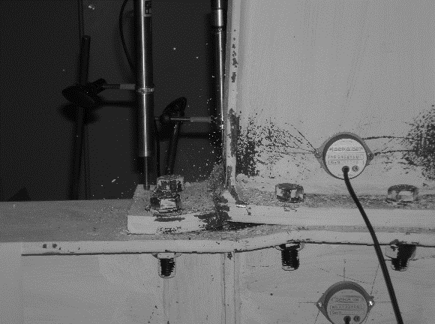
Fig. 3. Example of grey-scale photograph

5.3 Tables
An example of a table is given above (see Table 1). Place the tables centred; every table should have a title, at least indicating the number of the table. Keep the tables simple, do not use background colours or shadings to emphasise single cells, use bold letters instead and 8 pt text size.

Table 1. Paper sizes and margins
A4 (21.0 × 29.7 cm)
margins | [cm]
superior | 5.50
inferior | 6.00
left | 4.25
rigth | 4.25

6 Creating PDF files
Before creating PDF files the output quality probably has to be adjusted. The settings for output of bitmap images should not be less than the resolutions indicated in 5.1 and 5.2.

7 making references
Please provide a list of references at the end of the manuscript. For example this template has been prepared using hints given in [1] and [2]. The list of references should be numbered as given below, it should be referred to number of the publication in the list.
Every author is responsible for respecting copyrights on figures, trademarks etc. included in the contribution.

8 CONCLUSIONs
Each manuscript must be sent as two electronic files: one in .docx format (Word or RTF) and one in .pdf format (Acrobat Reader).
Please send the electronic copies (the .docx and .pdf files) of the full paper attached by email to: cta@ctanet.it
The final date for receiving the contribution is 30 June 2022. The final acceptation of the contribution will be given within 15 July 2022.

9 PRESENTATION of THE full paper
Presentation should be prepared in PowerPoint format. Time for oral presentation will be 10min. Author, at his own convenience, can present in English or in Italian language. In any case slides should be prepared in English language.

Acknowledgment
Acknowledgments shall appear before References. Do not provide a number for this heading.

References
- Hickernell B. K., Author's Manual for Preparation of Manuscripts for Conference Proceedings, Composite Constructions IV, 2000
- Dickert, D., Book Proceeding: Preparation of Manuscripts, ASCE Publications, 2002

KEYWORDS
Please provide 5 to 10 specific keywords, e.g. composite floors, dynamic actions, shear connectors, steel sheeting, acceptance criteria …

